Random Steps and Choices

Look at this code:
import random
random.seed(4)
even_step = random.randrange(2, 13, 2)
colour = random.choice(["red", "blue", "gold"])
print("Move:", even_step)
print("Colour:", colour)

What do you think this code will display?
Click or tap here to enter text.

Run the code. Compare the result with your prediction:
Click or tap here to enter text.

Let’s investigate! Answer the questions below:
- Why can random.randrange(2, 13, 2) produce 12 but not 13?
Click or tap here to enter text.

- Why can random.choice() return only an item already present in its collection?
Click or tap here to enter text.

- Why does using the same seed produce the same two results when the starter program is run again?
Click or tap here to enter text.

- With seed 4, what two output lines appear?
Click or tap here to enter text.

Random Steps and Choices

Look at this code:
import random
random.seed(4)
even_step = random.randrange(2, 13, 2)
colour = random.choice(["red", "blue", "gold"])
print("Move:", even_step)
print("Colour:", colour)

Use the code above to help you. After completing each challenge below, run your program to test that it works correctly. Save each completed challenge program in a new file.

Programming Challenges

Challenge 1
Generate a multiple of 5 from 5 through 30. Keep seed 4 and display the result as Move.
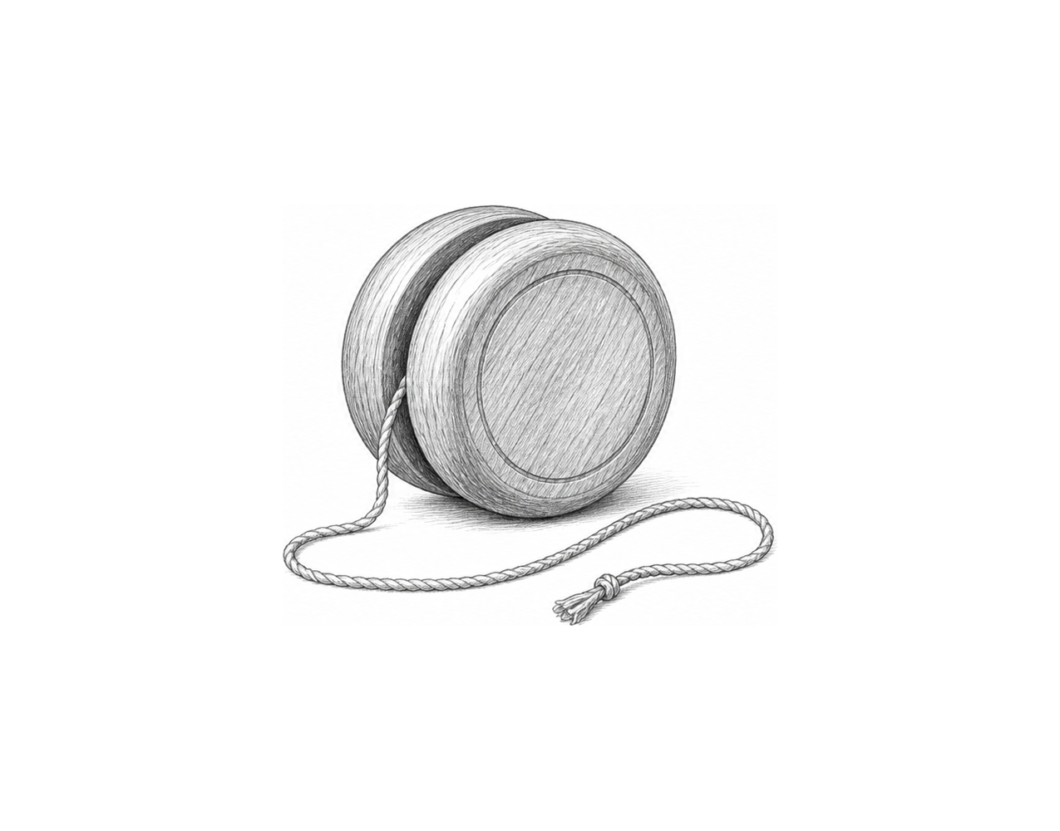

Challenge 2
Add "green" to the colour choices and generate two independently stored colour selections. Display both selections on labelled lines.

Challenge 3
Build a random training prompt. Choose an even repetition count from 2 through 12 and one activity from a three-item list you design. Display one instruction such as 8 jumps.

Random Steps and Choices

Fix the code!

This code has errors! Look closely at the code to find the problems:

import random
random.seed(4)
even_step = random.randrange(2, 12, 2)
colours = ["red", "blue", "gold"]
colour = random.choice
print("Move:", even_step)
print("Colour:", colour)

Rewrite the whole program in the box below with fixes to the errors.
Click or tap here to enter text.

After you are confident that you fixed all the errors, copy the code from the box and run it.

Did it work correctly on your first try? Did you find all the errors?
Click or tap here to enter text.

